Greetings all, Today’s bulletin is about the new Pick and Carry Crane Road Travel Driver Competency Initiative.
No heavy vehicle should pose a danger on our roads when driven by a trained, competent, licenced and medically fit operator. However, we do not live in a perfect world and incidents involving heavy vehicles still occur. In Bulletin 236, I discussed the voluntary reduction in maximum allowed road going speed of pick and carry cranes to 80kph. This is designed to increase the safety of operating these machines on public roads for both the operators and the general public. I went through the obvious physics and advantages in minimising the speed to a safer yet still commercially viable number, without creating a speed differential hazard.
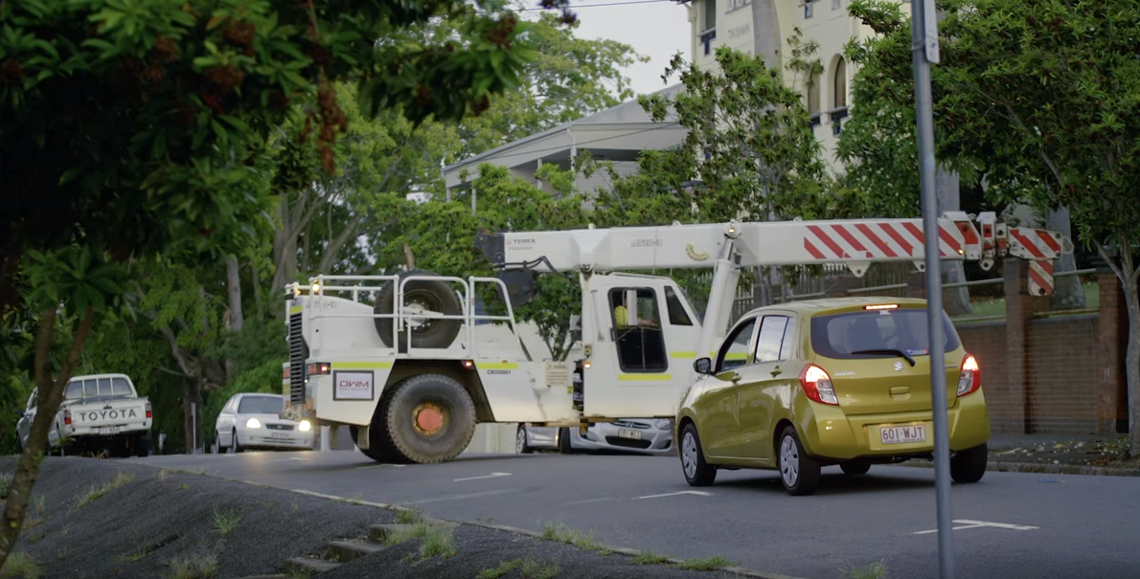
Like many other heavy vehicles and mobile plant, technology, re-designs and innovation tend to advance at a faster rate to our Licencing Framework. The result is, a single licence type allows a driver to legally operate a multitude of different vehicles on our public road network. Most new heavy vehicle modifications and variants are subtle (especially for freight vehicles) and involve an extra meter of length or tonne of mass. Where things get interesting is the addition of axles, articulation points and changes to the steering configurations. SPV’s, which include cranes, are a step further outside the conventional attributes of General Freight or PBS vehicles as they often include features like All-Wheel-Steer. In the case of the pick and carry crane, it has a central articulation point rather than steerable front wheels. Fundamentally, it’s no less safe, it’s just different.
Currently, Heavy Vehicle Licencing can only cover a certain number of variants, so the operator or their employer will ensure the drivers of these vehicles (after obtaining the appropriate licence) are further guided, mentored or trained to increase their familiarity and confidence in the vehicle.
The Queensland Government along with The Crane Industry Council of Australia, are developing and trialling an Articulated Crane Driving Course to formalise and refine this process. Verification of Competencies or VOC’s were discussed in Bulletin 222 but largely in relation to onsite work (Lifting) rather than driving cranes on the open road. 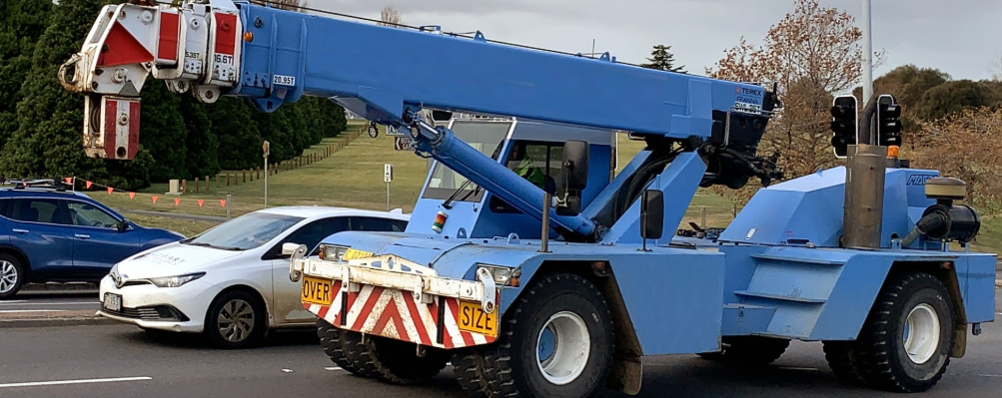
This unit involves the skills and knowledge required to obtain competency to drive an articulated mobile crane. It includes systematically and efficiently controlling all vehicle functions, monitoring traffic and road conditions, managing vehicle condition and performance, and effectively managing hazardous situations with a particular emphasis on the driving characteristics of an articulated mobile crane.
The primary legislative requirements applicable to this unit of competency are state/territory legislation in relation to high risk work licencing. Being awarded competency in this unit will be a necessary requirement to obtain an ‘Articulated Mobile Crane On Road Endorsement’ but is only one of several criteria. Prospective applicants should check with the state/territory driver licensing authority for other criteria (such as licence tenure and medical fitness) to confirm other eligibility requirements before undertaking training and/or assessment.
There is a bit of work to go on this one and the initial adoption will be confined to Queensland, but rest assured there is a significant opportunity to provide a consistent and well thought out solution to the challenges of ensuring your workforce is not only competent driving an articulated crane on a worksite but can also operate in an even safer manor, on public roads. Stay Safe -CICA

